**Upload a Project through GitHub Desktop on GitHub**

**Steps to Upload a Project using GitHub Desktop**:

1. Go to Github.com and browse to the repository you created in the GitHub. Just go to the main repo. (If you didn’t do the previous activity, just create a new repository.)

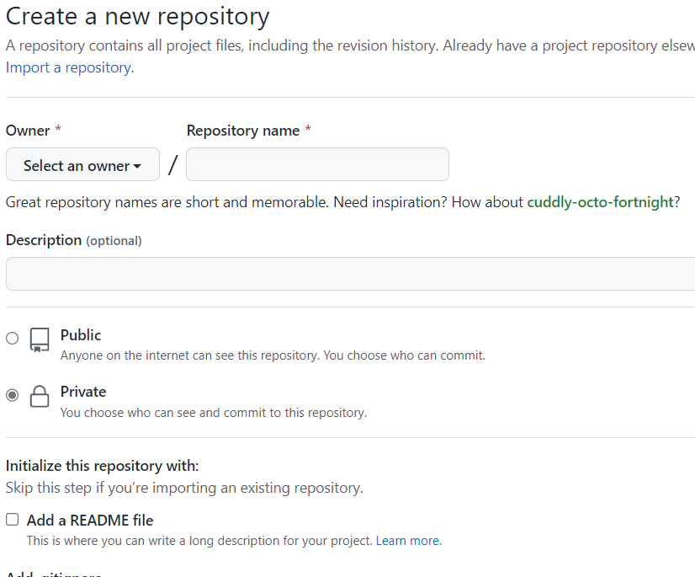

1. Now click on the “Open with GitHub Desktop” as shown below.

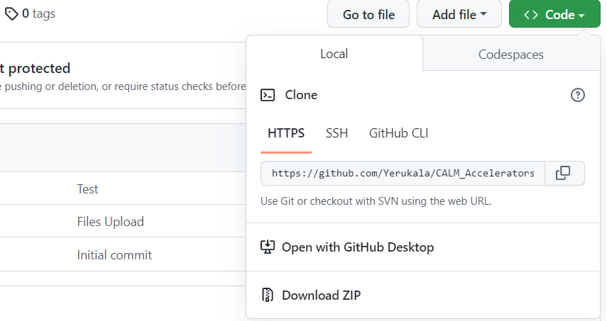

1. Choose the repository you want to clone from the list. Click “Choose” to select a local path where you want to clone the repository. When you’re done, click “Clone” to clone the repository:

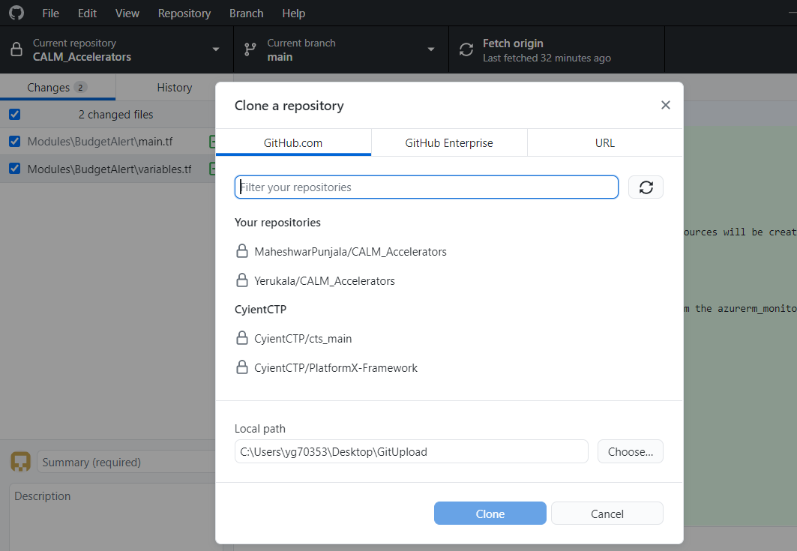

1. The result will be like this:

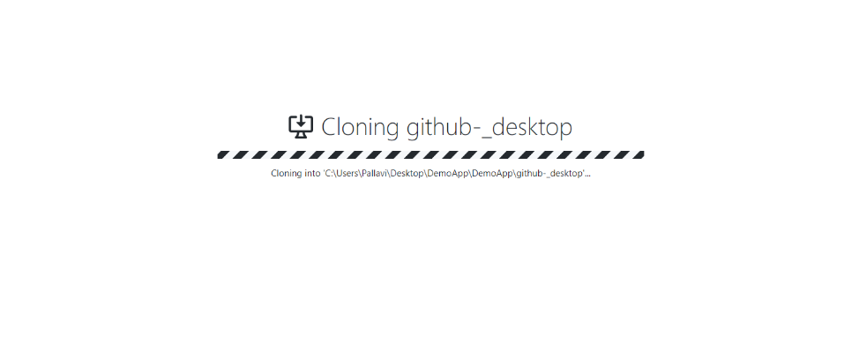

1. Copy files to the repository location:

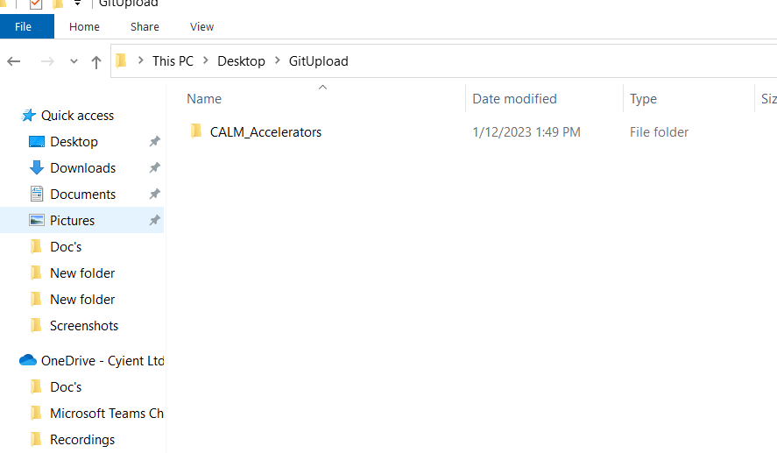

1. Once copying is done, move back to the GitHub desktop software. You should now see a notification for changes, there.

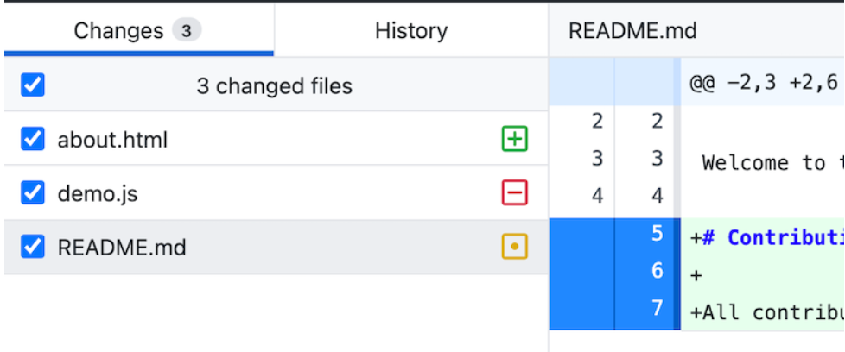

1. Different types of changes are represented by icons to the right of each file name.

* Modified files are shown with a yellow dot in a square.
* Untracked (newly created files) files are shown with a green plus sign (+) in a square.
* Deleted files are shown with a red minus sign (-) sign in a square.

1. In the lower-left corner of the GitHub Desktop client (where it says “Summary” and “Description”), type a commit message, and then click Commit to master or main.

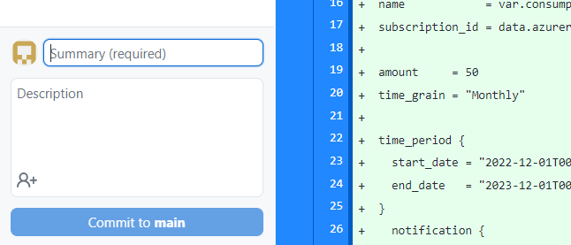

1. Click Push origin at the top.  
   You’ll see GitHub Desktop show that it’s “Pushing to origin.”



1. After all this click on the “Publish branch” and our file is uploaded on GitHub.

We can recheck our GitHub Repository whether it is uploaded or not.

